Name: | Vasundhara Singh
UID no.: | 2021700062
Experiment No. | 6
Class: | SE CSE(DS)
Batch: | D-4
Date of Experiment: | 03/04/2023

AIM: | Implement Dijkstra’s Algorithm for shortest distance between two vertices
PROBLEM STATEMENT: | Write a program to find shortest distance from source to each vertex in an undirected graph using Dijkstra’s Algorithm
THEORY: | Dijkstra algorithm is a single-source shortest path algorithm. Here, single-source means that only one source is given, and we have to find the shortest path from the source to all the nodes.  With Dijkstra's Algorithm, you can find the shortest path between nodes in a graph. Particularly, you can find the shortest path from a node (called the "source node") to all other nodes in the graph, producing a shortest-path tree.  This algorithm is used in GPS devices to find the shortest path between the current location and the destination. It has broad applications in industry, specially in domains that require modeling networks.  - Dijkstra's Algorithm basically starts at the node that you choose (the source node) and it analyzes the graph to find the shortest path between that node and all the other nodes in the graph.  - The algorithm keeps track of the currently known shortest distance from each node to the source node and it updates these values if it finds a shorter path.  - Once the algorithm has found the shortest path between the source node and another node, that node is marked as "visited" and added to the path.  - The process continues until all the nodes in the graph have been added to the path. This way, we have a path that connects the source node to all other nodes following the shortest path possible to reach each node.
PROGRAM: | #include <limits.h>  #include <stdbool.h>  #include <stdio.h>  int minDistance(int V, int dist[], bool sptSet[])  {  int min = INT_MAX, min_index;  for (int ver = 0; ver < V; ver++)  {  if (sptSet[ver] == false && dist[ver] <= min)  {  min = dist[ver];  min_index = ver;  }  }  return min_index;  }  void printSolution(int V, int dist[])  {  printf("\n\nVertex \t\t| Distance from Source\n");  printf("-----------------------------------------\n");  for (int i = 0; i < V; i++)  printf("%d \t\t|\t %d\n", i, dist[i]);  }  void dijkstra(int V, int weight[V][V], int src)  {  int dist[V];  bool sptSet[V];  for (int i = 0; i < V; i++)  {  dist[i] = INT_MAX, sptSet[i] = false;  }  dist[src] = 0;  for (int count = 0; count < V - 1; count++) {  int u = minDistance(V, dist, sptSet);  sptSet[u] = true;  for (int v = 0; v < V; v++)  {  if (!sptSet[v] && weight[u][v] && dist[u] != INT_MAX && dist[u] + weight[u][v] < dist[v])  {  dist[v] = dist[u] + weight[u][v];  }  }  }  printSolution(V, dist);  }  int main()  {  int s, e, w, v, ch;  printf("Enter no. of vertices: ");  scanf("%d", &v);  int weight[v][v];  printf("\nEnter edges and their weights:-");  do{  printf("\nStart Point: ");  scanf("%d",&s);  printf("End Point: ");  scanf("%d",&e);  printf("Weight: ");  scanf("%d",&w);  weight[s][e] = w;  weight[e][s] = w;  printf("\nEnter 0 to stop: ");  scanf("%d",&ch);  }while(ch!= 0);  dijkstra(v, weight, 0);  return 0;  }
RESULT: | 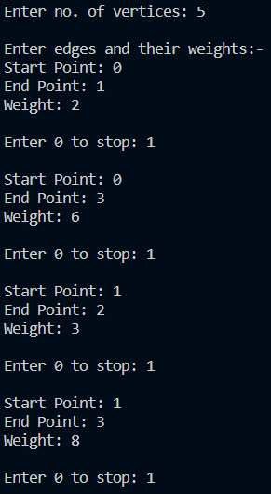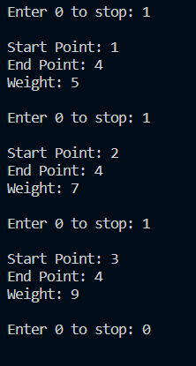  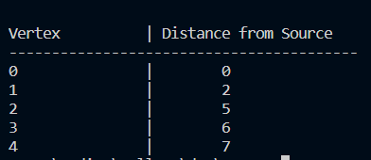
CONCLUSION: | We are able to implement Dijkstra’s Algorithm for finding the shortest distance between two vertices in a graph

